**Features you should know About Building Management System** 1

**What is this BMS?** 1

**Structure of BMS** 4

**Management level** 5

**Automation Level** 5

**Field Level** 5

**Features of Building management system** 6

**Man, and Machine Interface** 6

**System Security** 7

**Alarm management** 7

**Data logging /trending** 7

**Time scheduling** 7

**Remote connectivity** 7

**Benefits of Building Management System** 8

**Case study of Smart Building Technology** 9

# **Features you should know About Building Management System**

## **What is this BMS?**

You must have seen The Burj Khalifa, world’s tallest building, lit up with the colours of the Indian flag on 15th August 2020. You may be surprised How has it happened?

Well, the answer is that the Burj Khalifa is an Intelligent building.

Not only ***Burj Khalifa*** but there are other intelligent buildings around the world.

The edge- Amsterdam, Netherlands,

DPR Construction- San Francisco, California, United States,

Tottenham Hotspur Stadium- London, England, UK

Hindmarsh Shire council corporate centre, Australia

Duke-energy Centre, Charlotte, NC

Capital Tower, Singapore

The Crystal, London

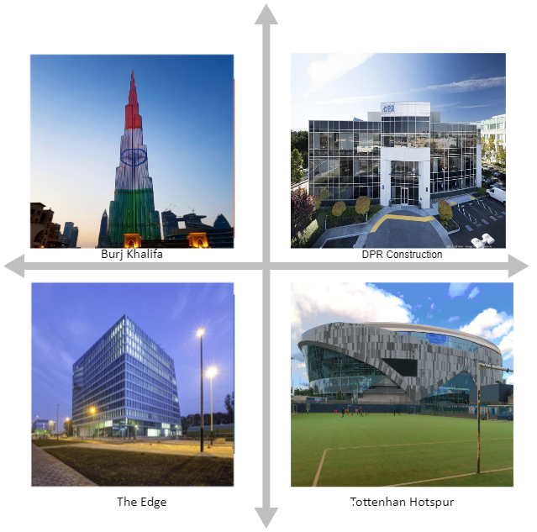

**Intelligent building???**

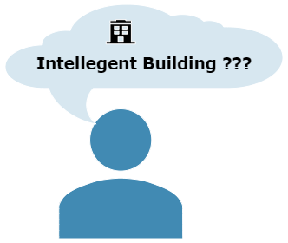

Intelligent buildings are components of a *Building management system*. In other words, it is a Building automation system.

BMS is an intelligent and integrated building management. It is a computer-based control system that needs to be installed within buildings.

It monitored and regulate the electrical system, mechanical system and the low current system of the building.

|  |  |  |
| --- | --- | --- |
| Electrical System | Mechanical System | Low current system |
| Ring Main Unit (RMU) | **Chillers** | **Data system** |
| Transformer | **Chilled Water pumps (primary and secondary)** | **Lighting control system** |
| Panels | **Air Handling Unit** | **Fire alarm system** |
| Generator | **Fan Coil Unit** | **Access control system** |
| Electrical meters | **Variable air volume** | **Closed Circuit Television (CCTV)** |
|  | **Duct heaters** | **UPS** |
|  | **Fans (Exhaust, Jet, Pressurization, Smoke)** | **Water leak detection system** |
|  | **Elevators** | **Security control** |
|  | **Pumps (Firefighting, Domestic, Sump, Irrigation)** |  |

BMS is the foundation of modern building energy management efficiency. This smart technology system connects the building’s HVAC, lighting, security and protection system. It enables them to communicate on a single platform to deliver the required information. BMS makes you smarter, savvier decisions while enhancing tenet’s comfort, safety and productivity at reduced cost and time.

The study shows BMS market is expected to reach USD 19.25 billion by 2023.

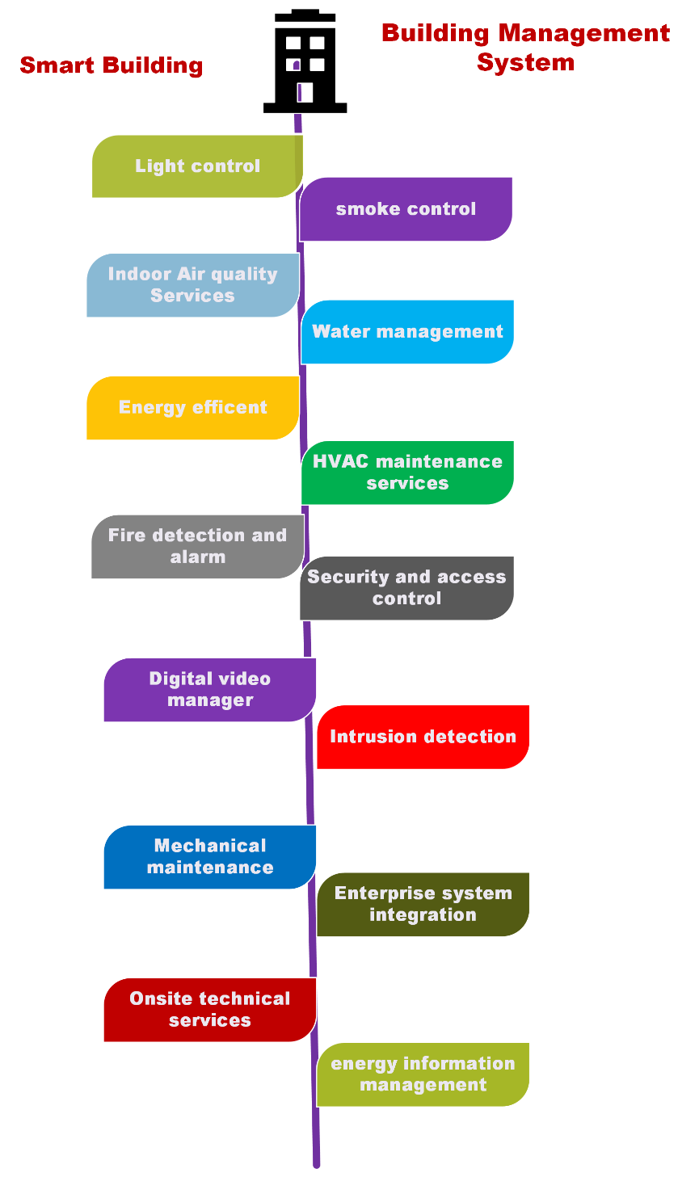

Buildings today, are not just meant to offer a roof overhead. They have grown into smart facilities with an integrated infrastructure that makes life and job easier, safer, and more comfortable.

## **Structure of BMS**

BMS is a three-level structured system

1. Management level/Workstation Computer
2. Automation level/DDC Controllers
3. Field level/ Field devices

### **Management level**

This is the top layer of the structure. It is used for everyday building operations. It is equipped with powerful user-friendly software.

### **Automation Level**

At this level, microprocessor-based fully programmable controllers exist. These are known as DDC controllers. These controllers help in monitoring and controlling all systems.

### **Field level**

At this level, all the devices are placed in the buildings. Here all the Sensors, actuators, dampers and VFDs etc are placed.

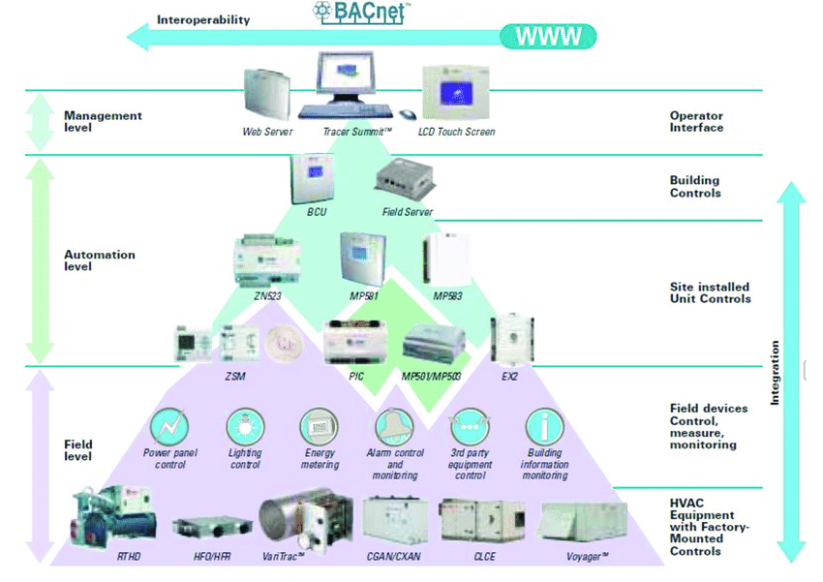

image source- internet

Hierarchal Order of centralised Building Management System

## **Features of Building management system**

Automated Control of a building’s HVAC, security system, electrical, lighting, shading, and access based on collecting and analysing data on environmental conditions, occupant behaviour and more.

### **Man, and Machine Interface**

Through man and machine interface, we can interact with the connected building equipment. It provides a user-friendly floor layout and graphics for equipment. These graphics and layout are very helpful for operators, engineers and building management.

### **System Security**

It Provides full system security.

* It prevents unauthorised access to the system.
* It is password protected.
* It limits access to limited areas.
* Different accesses to users, engineers and operators.

### **Alarm management**

* BMS presents different alarms in the sequence of importance and time.
* Different priorities can be configured for alarms.
* Most critical alarms popup on the top of the list.
* Different sets of instructions are set to the alarms which guide operators to take appropriate action.
* Alarms can also be notified through emails and SMS.

### **Data logging /trending**

* It is the automatic gathering and storage of data from field level (lower level) equipment for later analysis.
* This data represents in the form of tables, graphs and charts.

### **Time scheduling**

* A time preset can be set to an ON-OFF status of the equipment.
* For example-lights can be set as, evening 6-start, morning 6-off, to save the light.
* Daily/weekly time can be scheduled for holidays or events.

### **Remote connectivity**

* BMS provides remote access to the system with full functionality through local area networks or the internet via a web browser.

## **Benefits of Building Management System**

1. BMS improves indoor environment quality.
2. Faster response to occupants’ needs.
3. Faster response to end-user complaints and trouble conditions.
4. Integration Capabilities
5. There is no need to construct or move to a new building to benefit from the smart technology.
6. Modern smart building solutions can be embedded into the older structure.
7. **Cost optimization**

* It analyses the building’s usage patterns.
* It makes adjustments to improve building upkeep, optimize operations, match occupancy patterns to energy use, and enhance space utilisation efficiency.

1. **Maintenance Saving**

* Efficient control gives less wear and tear.
* Efficient control gives less strain on the mechanical equipment
* It provides longer life to the mechanical equipment
* Runtime monitoring alerts timely maintenance of equipment
* If we keep maintaining every strain at the time of starting, it will avoid expansive failure.
* Analysing real-time historical equipment data and detecting patterns leading to a potential failure.

1. **Energy saving**

* It saves energy through the optimum use of electricity.
* It eliminates unnecessary system operation.

1. **Consolidated facility control**

* It offers a one-point centralised operation
* It offers simpler operations
* It reduces cost, time and resources.

1. **Reduced operator training**

* It provides on-screen instructions
* It provides a user-friendly display
* Simpler operation programmed for routine and repetitive operations.

1. **Improved management reports**

* It provides valuable real-time data.
* It creates reports and charts.
* Critical information immediately emailed, SMS and sent to the printers

1. **Timely and effective control**

* It alerts your employees when your facility is not operating correctly

1. **Enhance the health and well being**

* It supports physical distancing efforts through space optimization and an access control system.
* It improves indoor air quality through efficient HVAC operation, and more.

1. **Comfort for occupants**

* Due to controlling lighting, temperature, humidity, and other parameters and allowing for personalised comfort.

In simple words, Building Management System delivers a comfortable and safe environment for your building by controlling.

## **Case study of Smart Building Technology**

**This is a case study of intelligent building, the Edge, Amsterdam. This building is a Smart Office.**

**Smart offices**like the Edge in Amsterdam, Netherlands, control building operations as per workers’ needs. It enhances employee gratification and productivity.

For example, with the help of a special app, the Edge knows the routine of each of its inhabitants: it books workplaces based on their work schedules, knows which cars they drive and takes care of parking measures accordingly.

It remembers each inhabitant’s lighting and temperature preferences. Every aspect of building operation from energy use to coffee maker is monitored via its central dashes.

It helps in optimising building resources and cutting upkeep costs whenever possible.

**Smart offices** are also proficient in addressing global challenges like air purification or fighting temperature variations.

Glumac’s Shanghai office in China ensures the best indoor air quality with its Five air purification systems.

Smart infrastructure makes you live freely and standard life. You must check in to the new world of technology, that is Building Management systems.

Namita Singh